September 4th – November 6th 2018

Love & Qi

“Love is energy. Love is the original energy and the basic energy of the universe. From Love comes Qi.

With Qi, with Love, there is great power. Our bodies become healthier and emotions become better.” Master Li JunFeng

This class will be an exploration into the original energy of the universe practicing several forms as well as exploring poetry and song.

Barcroft Community House, 800 S. Buchanan St., Arlington, VA
6:30pm to 7:45pm $140 for ten weeks Drop-ins $20
Registration at the site

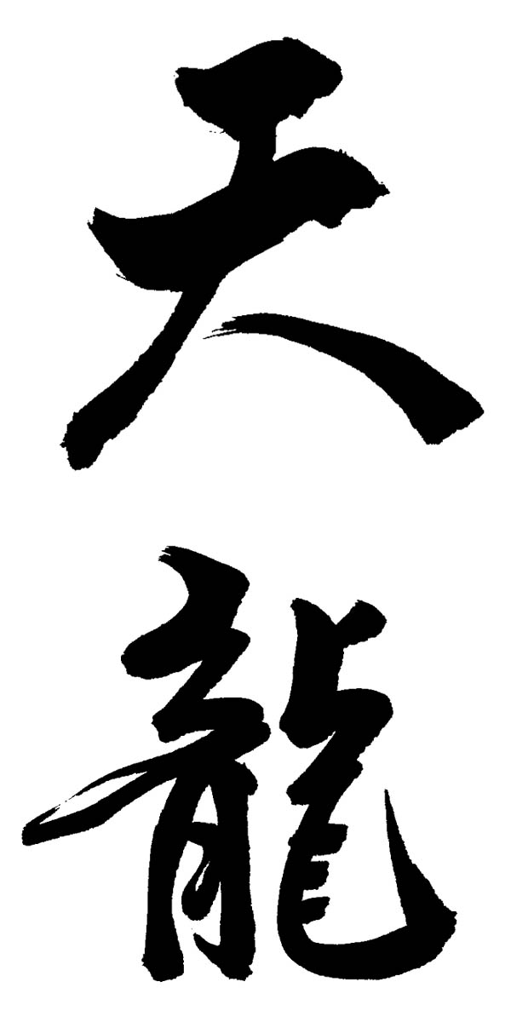
Paul and Nancy Rischard & Friends
Members of the Peaceable Dragon Internal Arts Consortium

